Group Notes/Encounter Collection
User Manual



October 2004

Revised August 2014

Department of Veterans Affairs
Office of Information and Technology (OIT)
Product Development

Revision History
Date | Version | Description | Author
08/2014 | 1.3 | Updated Title Page, Revision History, Table of Contents and renumbered pages.  Updated Index, page 19.  Updated for ProPath template compliance. Made corrections to reference a generic Provider and Clinic in screenshots. Added ICD-10 information to screenshots on pages 10-16.  For patch OR*3*353, changed “ICD-9” to ICD-10, or just “ICD” where appropriate. | VA PM: Kristen Templet  HP PM: Mike Klein  TW: Corrie DeCapua
08/2014 | 1.2 | Updated for ProPath template compliance. Made corrections to reference a generic Provider and Clinic in screenshots. Added ICD-10 information to screenshots on pages 9 -15.  For patch OR*3*353, changed “ICD-9” to ICD-10, or just “ICD” where appropriate. | VA PMs: Rich Holmes/ Kristen Templet  HP PM: Mike Klein  TW: Corrie DeCapua
11/01/2004 | 1.1 | Name Sanitation | Charles Arceneaux
10/18/2004 | 1.0 | First Draft | Charles Arceneaux

(This page intentionally left blank)
Table of Contents
Introduction 1
Purpose of Group Notes 1
Scope of the Manual 1
Audience 1
User Section 3
Group Notes Operation 3
Visit Information 4
Patient Selection 5
Common Encounter Data Entry 6
Common Note Title 7
Common Encounter Entry 9
Individual Note Text Entry 11
Individual Encounter Entry 12
Group Signing 13
Repeat 15
Glossary 17
Index 19

(This page intentionally left blank)

Introduction

Purpose of Group Notes
This program was designed to assist providers in documenting group therapy sessions and events such as immunization clinics. It allows the easy assembly of patient groups based on Clinics, Specialties, Wards, Teams, or Provider lists. It then allows the note author to specify parts of a note that apply to the entire group and parts that apply to individuals. It does the same with encounter data. After the note and encounter information is complete, it provides for a single signature for the entire group.

Scope of the Manual
Tasks associated with Group Notes are: System setup, workstation setup, creation of notes for a group, and collection of encounter data. This manual provides information deemed necessary to carry out these functions.
From time to time improvements are made to the TIU package, including improvements to Group Notes. The latest information about TIU, as well as the latest version of this manual, is posted on the Text Integration Utilities (TIU) Web Page at:

vista.med.va.gov/tiu/html/Enhance.htm
or
vaww.vista.med.va.gov/tiu/html/Enhance.htm

This document is intended for use during development and testing of the Group Notes executable. When Group Notes is released this document will cease to exist as a living document and the information in it will be inserted into the appropriate VistA manuals. (However, the document will continue to be available on the above page—it will not be updated with post-release changes.)
Also on release, information about Group Notes will be available on the TIU page of the VDL (VistA Document Library) at http://www.va.gov/vdl/application.asp?appid=142.

Audience
Information in this manual is intended for end users. This usually means providers conducting group sessions and limited scope clinics such as for training or vaccination.
(This page intentionally left blank)

User Section

Group Notes Operation
Group Notes is a companion to the CPRS (Computerized Patient Record System) Notes tab. If you are familiar with creating clinical notes in CPRS you will have little trouble with Group Notes.
Creating notes for a group of patients who have just participated in a group therapy session, education, or an immunization clinic follows these steps:

- Set the visit location and the date/time for the encounter.
- Select the patients involved, compiling them into a list.
- Select a note title common for the group.
- Enter note information common for the group.
- Enter encounter data that is common for the group.
- Select individual patients and enter encounter and note information unique to each individual.
- Sign the notes.
- Go back to the patient selection screen and repeat for additional groups.
If you are interrupted and exit the session before signing the notes, Group Notes will file notes individually unsigned and generate notifications that there are notes awaiting signature. Any work subsequent to exiting Group Notes must be accomplished in CPRS.

Visit Information
Information filled in or provided in the Group fields (upper right corner) is carried forward by the program into the encounter fields.
Check that the provider is correct.

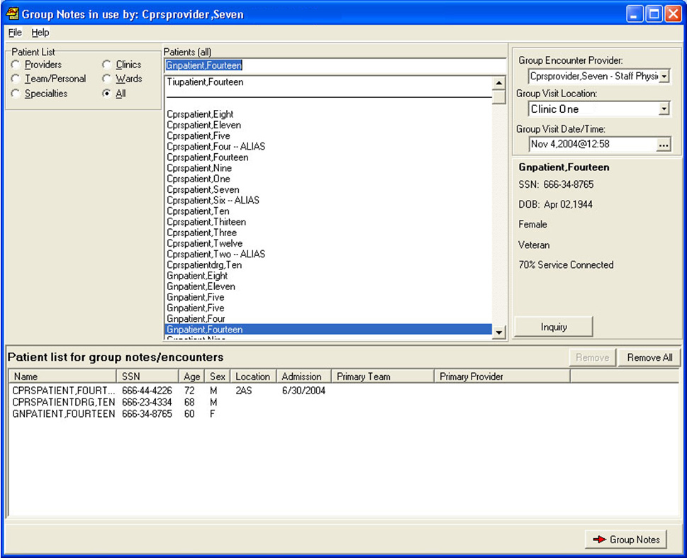
Check that the visit time is correct.
Set Location here.

Patient Selection
As with CPRS, Group Notes opens with the patient selection screen. This screen is very similar to the CPRS patient selection screen with a number of fields and buttons added to facilitate group notes.
Select a patient list.

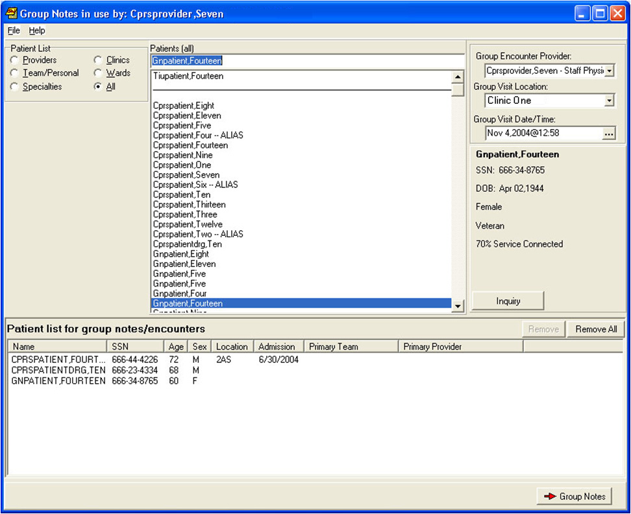
Select patients by clicking on their names
Patients are listed here.
This button supplies additional demographic information.
Click here when the list is complete.

☞ Note: If the patients are being selected from a clinic appointment list, the date and time of the visit MUST match exactly the date and time of the appointment. If there is a mismatch, you will create a duplicate encounter.
An extra button is added below patient demographics that, when pressed, displays detailed patient demographic information. Finally there is a list box provided showing the patient list as you build it.
With the patient list there are two additional buttons: Remove and Remove All. These have the obvious function allowing you full edit control over the list. Once you are satisfied press the Group Notes button.

Common Encounter Data Entry
☞ Note: Information common to the entire group must be entered before data for an individual patient.
Pressing the Group Notes button moves to the note-building dialog screen. To return to patient selection (to add or subtract patients) use the Patient Selection button.
Until you change it by selecting an individual patient, all actions will apply to the entire group.
Use this button to modify visit and provider information

Use this button to select a note title.
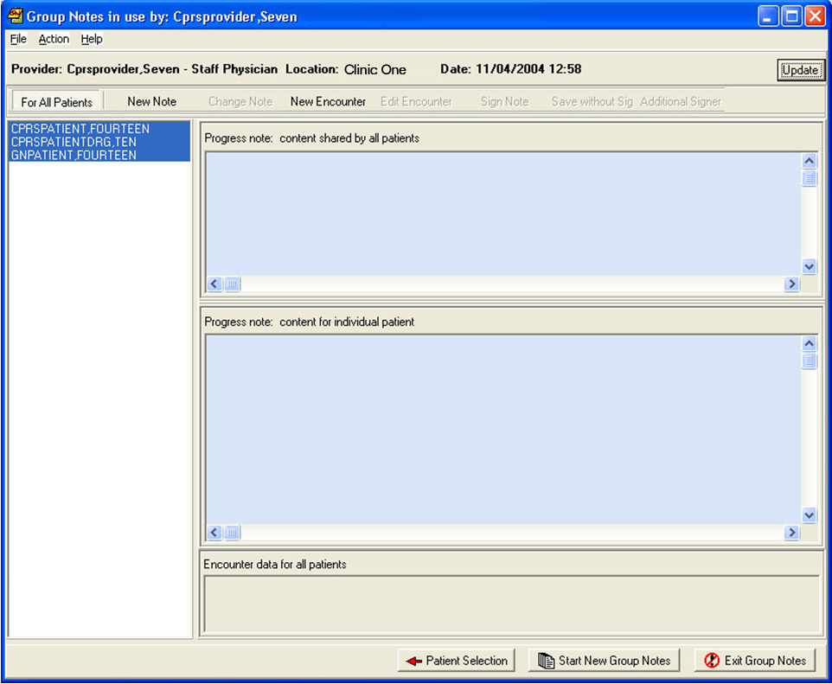
Use this button to enter group encounter information.

Common Note Title
Pressing the New Note button will allow you to select a note title. This will be the note title used for each member of the group:

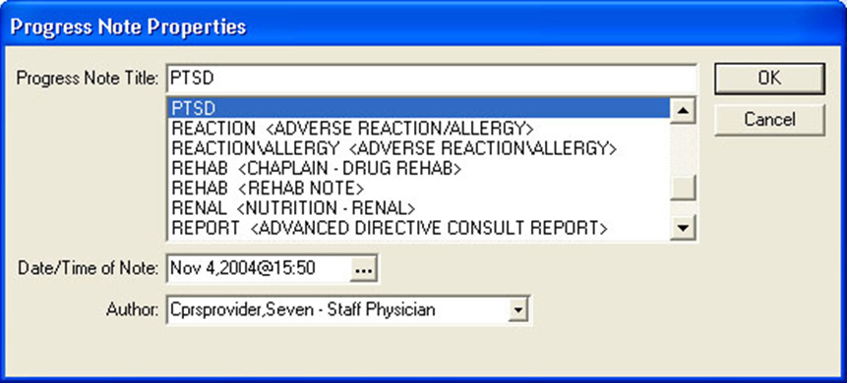
☞ Note: If the provider requires a co-signer, the co-signer must be designated at the time of note title selection. The field for designating a cosigner appears only if the author of the note requires a cosigner. The requirement for cosigner is a product of the author’s User Class and the set up of the document in TIU.
This is the “point of no return.” Once you select a title, a note will be created for each member of the group. If you exit the program without signing, unsigned notes are created for each member of the group and notifications will appear in CPRS that a note awaiting signature is available for each of these patients.
☞ Warning: Objects in boilerplate are problematic for group notes. The first patient on the list gets filled in and then the note text is given to each patient. So, do not use objects in the boilerplate of these notes titles that would be different for each patient.

Common Note Text Entry
If the note title selected contains boilerplate text, it will appear in the Common note content pane. You may edit the contents of this boilerplate and/or add additional text.

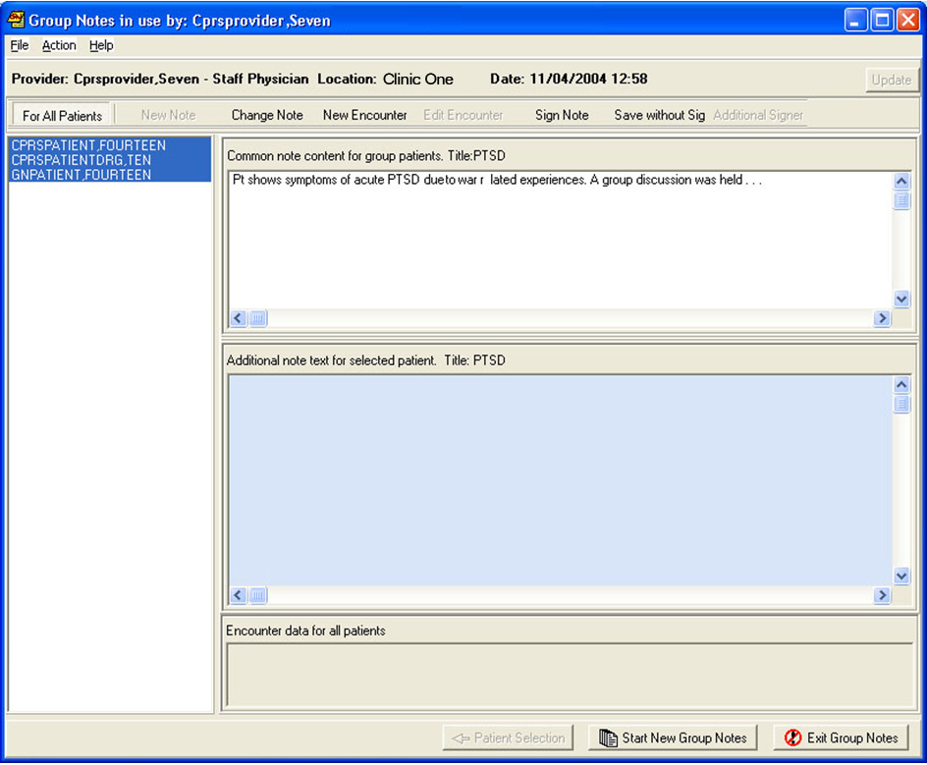
Add or modify common note text.
When ready, press this button to continue on to common encounter data.
☞ Note: For CACs and ADPACs: When setting up boiler plate that will be used in Group Notes be aware that inserted objects that import specific patient data will not work properly. Generally speaking, do not put TIU objects in this boiler plate. Exceptions to this rule are objects that are general in nature such as the current date.

Common Encounter Entry
The Group Notes encounter form is customized for group entry. At this point in the program only tabs that would be common to all patients are displayed:

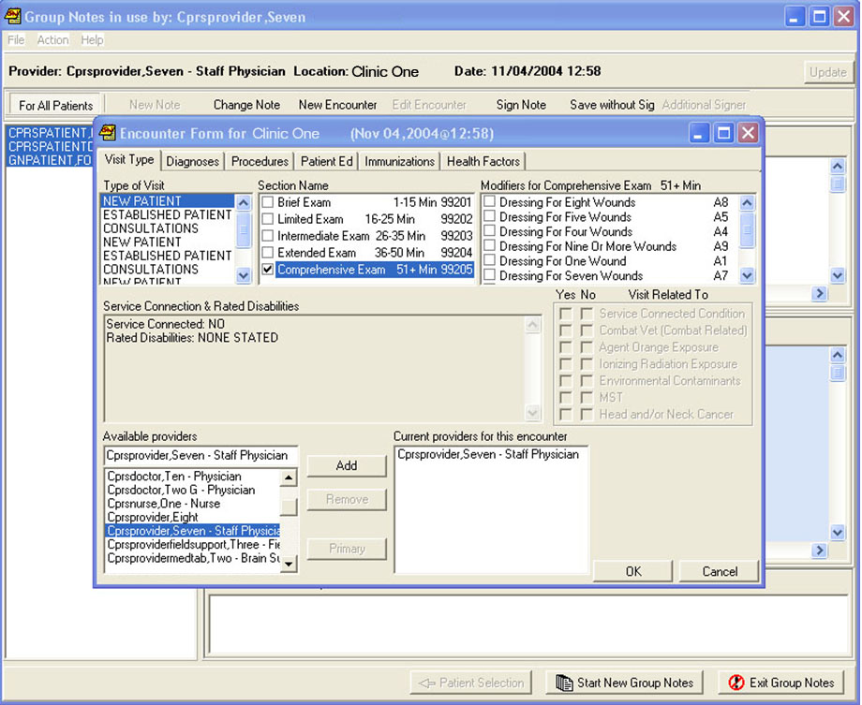
When finished press the OK button.

Fill out the encounter form the way you would normally perform this operation, and then press the OK button.
Select an individual patient by clicking on the patient’s name:

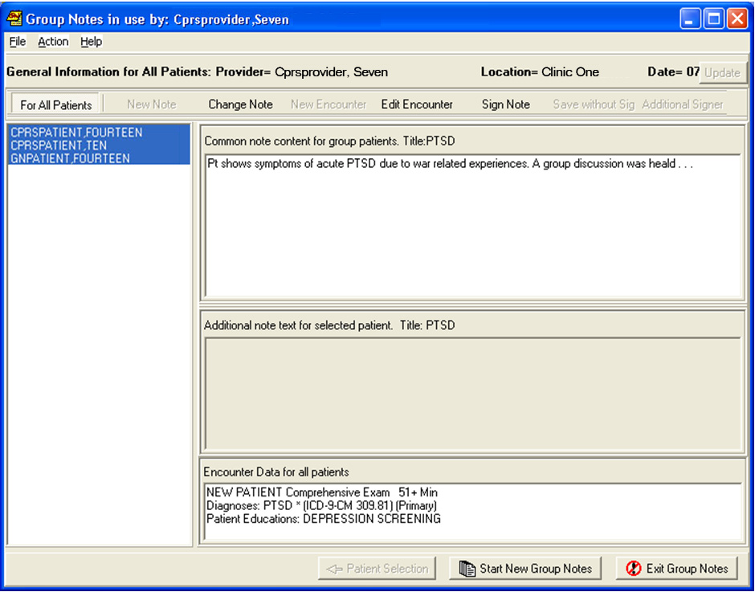
Group encounter data appears in this pane.

ICD-9-CM Diagnosis information will display if the encounter date is prior to the ICD-10-CM activation date.

ICD-10-CM Diagnosis information will display if the encounter date is on or after the ICD-10 activation date.
When finished with common data, select a single patient that you need to enter individual data for.

Individual Note Text Entry
When an individual patient is selected, the Additional note text pane becomes active.

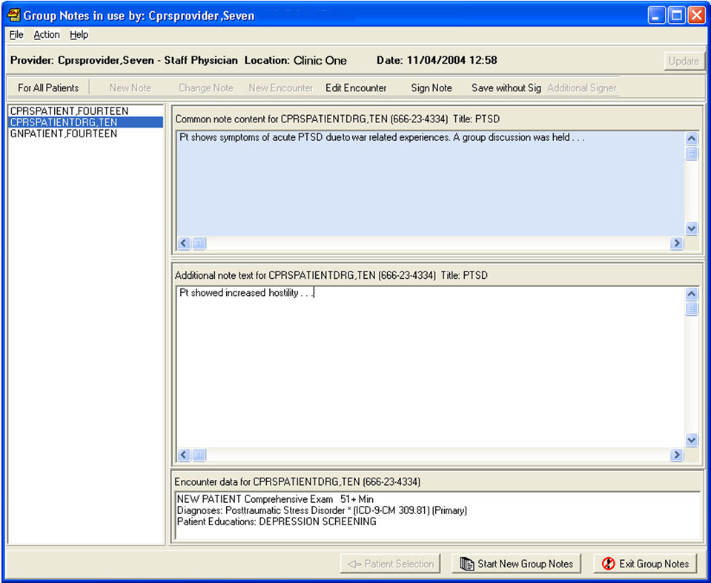
Type information specific to the selected patient here.
Repeat for each patient that needs specific note text.
When finished customizing individual notes, press this button to customize individual encounter data.
ICD-9-CM Diagnosis information will display if the encounter date is prior to the ICD-10-CM activation date.

ICD-10-CM Diagnosis information will display if the encounter date is on or after the ICD-10 activation date.

Individual Encounter Entry
When an individual patient is selected the encounter form now shows all tabs.

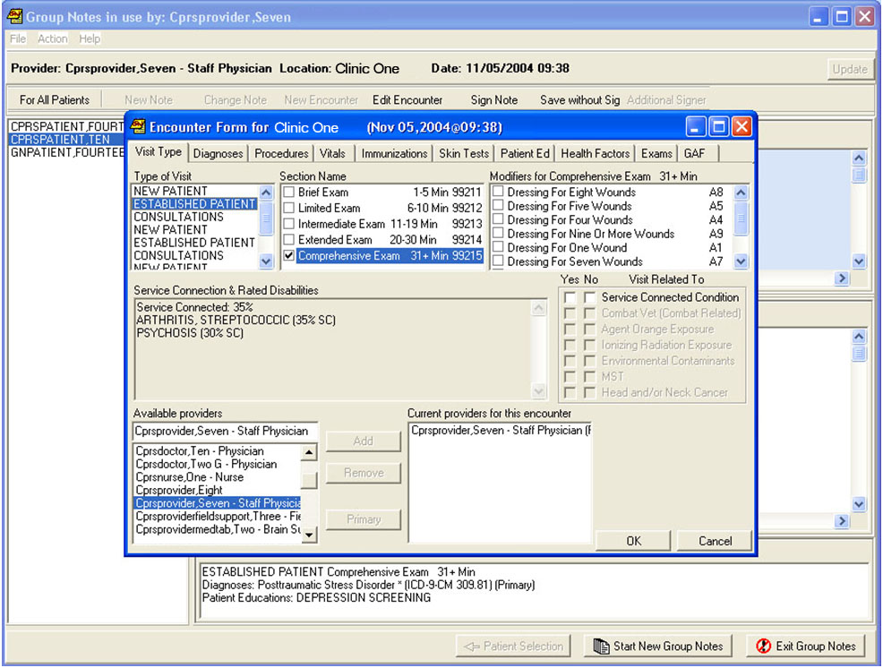
Encounter data that applies only to this single patient may now be entered.
If the patient is in any of these categories, you must indicate if the group session was related.
ICD-9-CM Diagnosis information will display if the encounter date is prior to the ICD-10-CM activation date.

ICD-10-CM Diagnosis information will display if the encounter date is on or after the ICD-10 activation date.

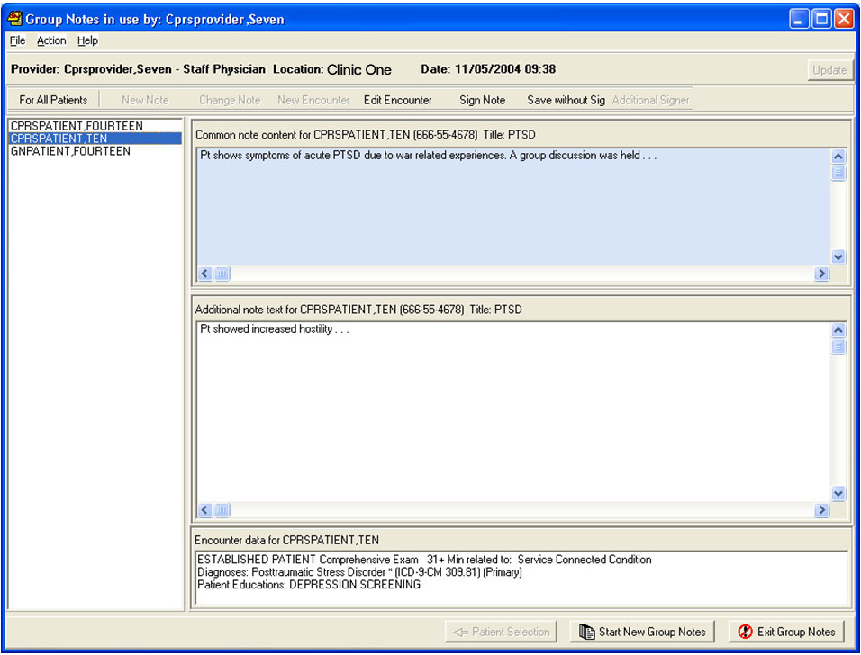
When all data has been entered press the sign note button.
The individual encounter data only appears when that patient is selected.
ICD-9-CM Diagnosis information will display if the encounter date is prior to the ICD-10-CM activation date.

ICD-10-CM Diagnosis information will display if the encounter date is on or after the ICD-10 activation date.

Group Signing
When the sign note button is pressed the program automatically selects For All Patients. If any encounter data is missing such as service connected status, the program will prompt you for it at this time.
When you sign the note, you are signing for every patient in the group:

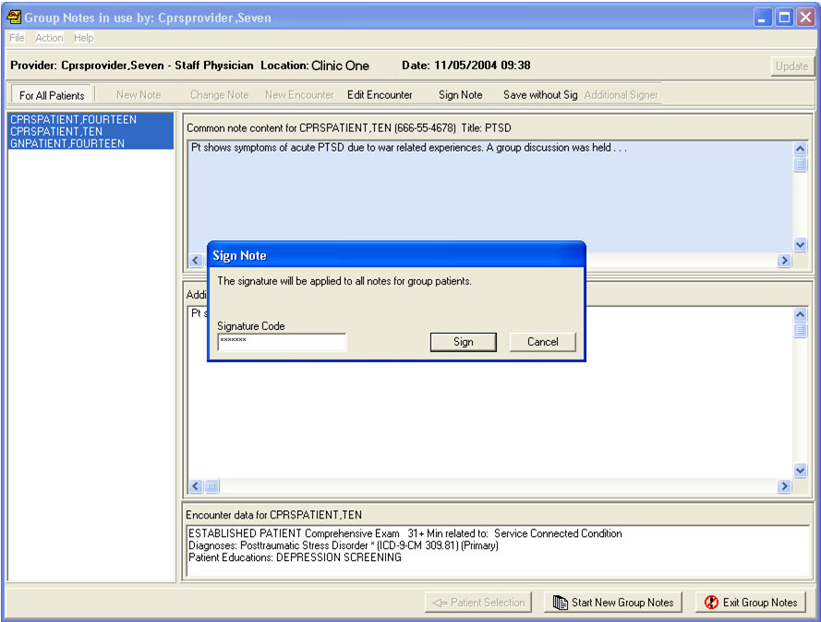
When you sign the note you are signing for every patient in the group.
ICD-9-CM Diagnosis information will display if the encounter date is prior to the ICD-10-CM activation date.

ICD-10-CM Diagnosis information will display if the encounter date is on or after the ICD-10 activation date.

If business rules specify that you need a cosigner, then notifications will appear in CPRS to the effect that the expected cosigner has notes ready to sign.
After the signature has been accepted, the Additional Signer button becomes active. If this button is pressed the following dialog appears:

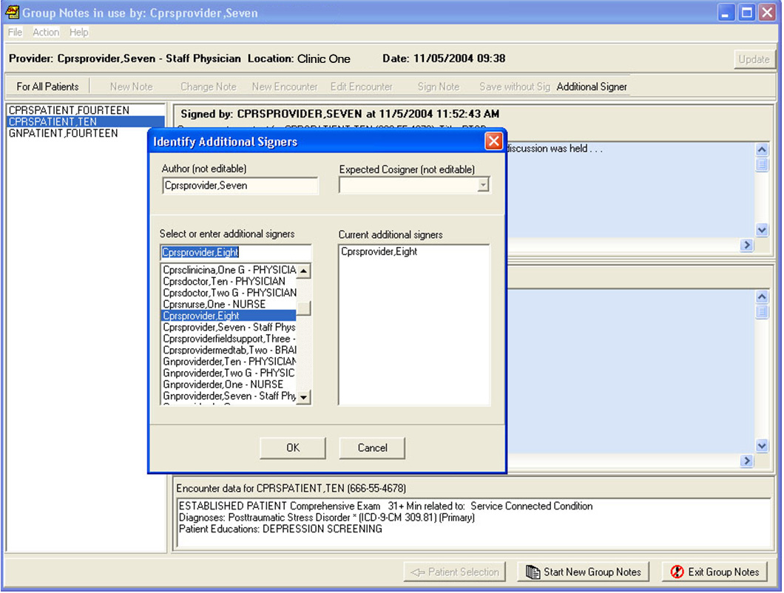
Notice that the Additional Signer button is now active.
Only a single patient can be selected.
ICD-9-CM Diagnosis information will display if the encounter date is prior to the ICD-10-CM activation date.

ICD-10-CM Diagnosis information will display if the encounter date is on or after the ICD-10 activation date.

Repeat
To return to the patient selection dialog with a clean slate to enter another group, press the Start New Group Notes button. Otherwise press the Exit Group Notes button

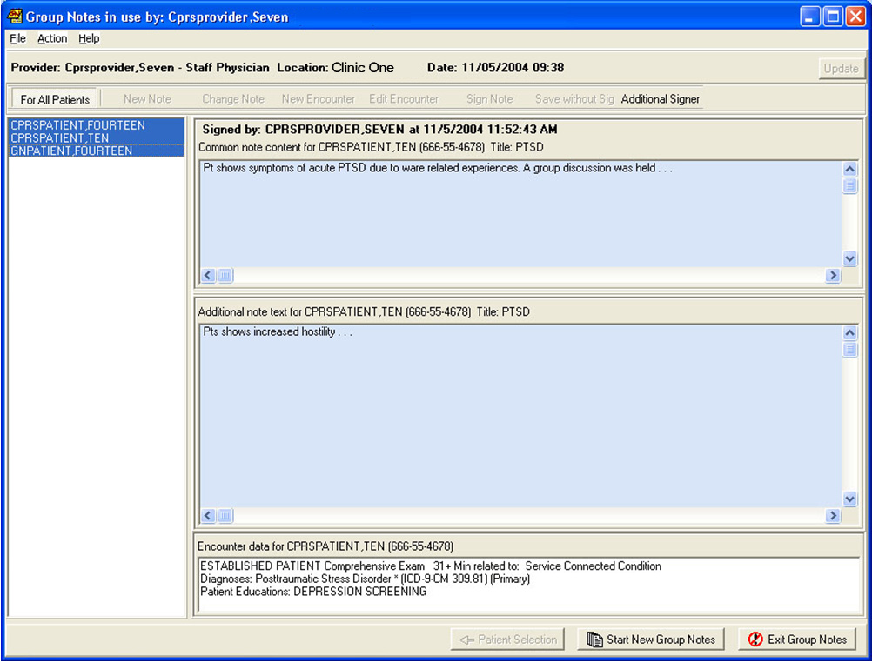
When signed, this notice appears and you may not make any further changes.
Press this button to start over on a new group.
ICD-9-CM Diagnosis information will display if the encounter date is prior to the ICD-10-CM activation date.

ICD-10-CM Diagnosis information will display if the encounter date is on or after the ICD-10 activation date.

Glossary
ADPAC Automated Data Processing Application Coordinator. A VistA software expert who usually works for IRMS.
Boilerplate A pre-defined TIU template that can be filled in for Titles, speeding up the text entry process. TIU exports several Titles with boilerplate text which can be modified to meet specific needs; sites can also create their own.
For Group Notes a title with information that would be common for each member of the group works well. Any TIU objects used in boilerplate are filled in as if for the first patient, so avoid objects in Group Notes boilerplate.
CAC Clinical Application Coordinator. A software specialist who usually works for one of the medical center services.
CPRS Computerized Patient Record System. A front-end program that attempts to provide all VistA functionality in a Windows interface. Currently CPRS is being re-written to work in any windowing system that supports a web browser. This will allow users to access VistA from UNIX and Macintosh based systems. The target date for release of this advanced system is third quarter 2005.
IRMS Information Resource Management Service.
TIU Text Integration Utilities. An umbrella package with the purpose of combining all clinical note processing into a single entity. In CPRS, TIU is represented by the Notes tab.
VDL VistA Document Library. A service of the Department of Veterans Affairs to provide documentation to all users. Anyone can access the VDL at web address: www.va.gov/vdl/

(This page intentionally left blank)

Index

A
Additional Signer, 15
ADPAC, 8, 16
Audience, 1
B
boilerplate, 7
Boilerplate, 8, 17
C
CAC, 8, 17
Common Encounter Entry, 9
Common Encounter Data Entry, 6
Common Note Text Entry, 8
Common Note Title, 7
co-signer,7
CPRS, 3, 5, 7, 14, 17
E
encounter data, 1, 2, 5
Encounter Entry, 9, 12
encounter fields, 4
encounter form, 9
Exit Group Notes, 16
G
Glossary, 17
Group Notes Operation, 3
Group Signing, 14
I
Individual Encounter Entry, 12
Individual Note Text, 11
Individual Note Text Entry, 11
Introduction, 1
IRMS, 17

O
objects, 7, 8, 17
P
patient list, 5
Patient Selection, 5
Purpose of Group Notes, 1
R
Repeat, 16
S
Scope of the Manual, 1
sign note, 14
Start New Group Notes, 15
T
Text Entry, 8
Title, 7
TIU, 1, 7,8, 17
U
User Section, 3

V
VDL, 1, 17
Visit Information, 4
W
Web Page, 1

(This page intentionally left blank)

